*Start a new Python project folder … do not reuse the previous workspace … As with any keyboard-driven console-like environment, developing muscle -memory for the common commands is also part of the learning curve.*

**Dictionaries** in Python

* Think of it as a lookup table
* These tables are sometimes called key-value pair
* 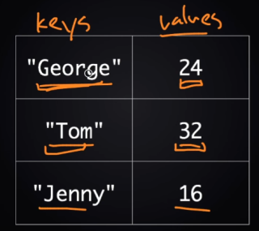
* The key “Tom” above is associated with value 32.
* You can use dictionary to store these types of information.
* To define an empty dictionary with no keys and no values
* 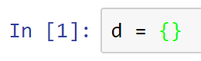
* You can also declare dictionaries with predefined values
* 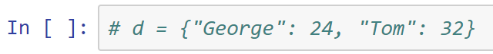
* You can add a key-value pair to a dictionary
* 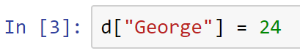
* In the code above, key “George” is associated to value 24
* Adding more key-value pairs to dictionary d
* 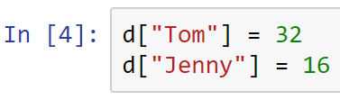
* To print the value from an associated key
* Printing the value associated to the key “George”
* 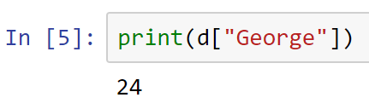
* Looking up the value of a key that does not exist yet will throw an error
* 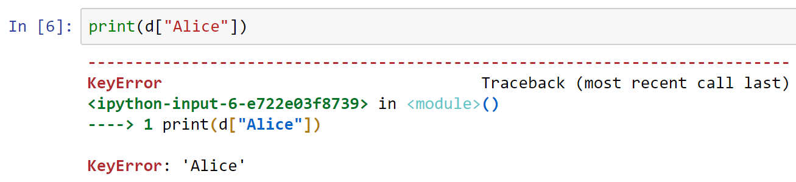
* You can change the value associated with a key
* 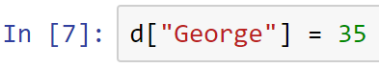
* Printing the key’s value will now display the modified version
* 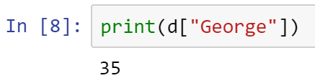
* Note that the values can be any type, but the keys can only be a certain types
* Keys are commonly strings or numbers
* In Python, you can mix different types of keys
* For example, you can add a numeric key associated to a numeric value
* 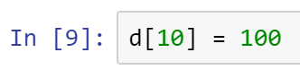
* To retrieve the value 100, print its key
* 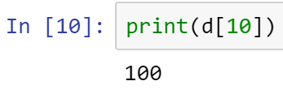
* Displaying the entire new dictionary
* 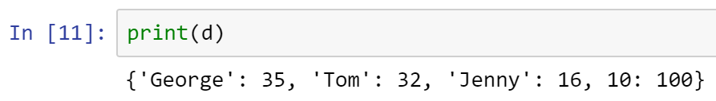
* How to iterate over key-value pairs?
* 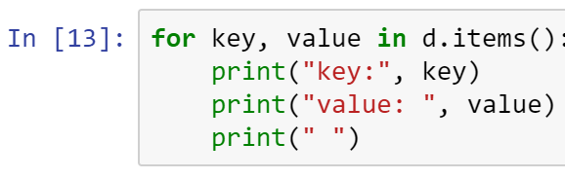
* 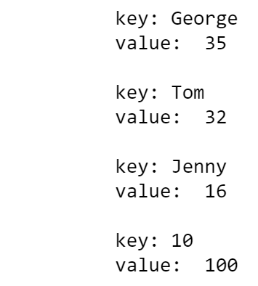
* Your turn: Create a key-value pair of U.S. state’s abbreviation with its associated full state name. You may create the first state only. Test that your state dictionary works!
* 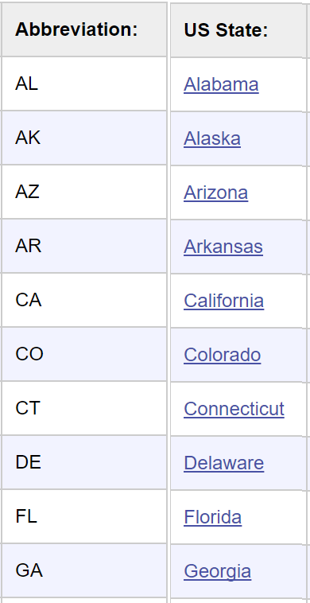
* Place your answer here below:

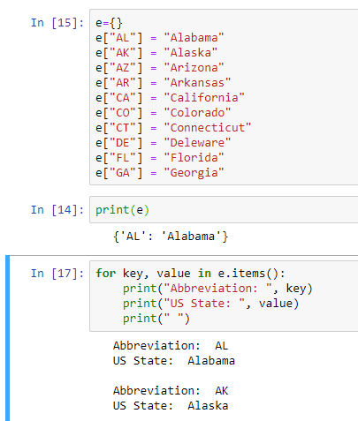

____________________________________________________________________________

* All submissions should be separate from other exercises and quests. Please do not lump all your answers into one document and re-using that same workspace to gain multiple points. Thanks.
* Place your name at the bottom of your code, download your Python program in html format, and submit your work in Canvas.